Drain based Irrigation Sheduling with Offline Reinforcement Learning in Protected Strawberry Cultivation
Abstract Abstract Abstract Abstract Abstract Abstract Abstract Abstract Abstract Abstract Abstract
In the abstract you present the most important points about the problem, material and methods, results, discussion and conclusion.
Abstract Abstract Abstract Abstract Abstract Abstract Abstract Abstract (approx. 900 characters)

Keywords
protected horticulture; strawberries; drainage; evapotranspiration; offline reinforcement learning; irrigation scheduling

Introduction 1.5
Protected strawberry production in Germany combines high market value with intensive resource use, placing irrigation management at the nexus of economic performance and environmental stewardship. Strawberries (Fragaria × ananassa) grown under protective structures such as greenhouses or high tunnels frequently rely on soilless substrates and table-top / gutter systems that decouple crop rooting volume from field soil buffering. This configuration enables precise climate and water control but also increases the sensitivity of the crop to irrigation timing and volume: shallow substrates and concentrated root zones mean that both water stress and over-watering manifest quickly, with direct impacts on fruit yield, size and post-harvest quality. At the same time, shifting climatic patterns in Central Europe, warmer growing seasons, more frequent heat spells and variable precipitation, heighten irrigation demand and complicate scheduling based on historical practice alone. For Germany’s horticultural sector, achieving higher water-use efficiency (WUE) while avoiding nutrient leaching and saline build-up is therefore a pressing operational and regulatory concern, especially in protected cultivation where water inputs are large relative to substrate volume.
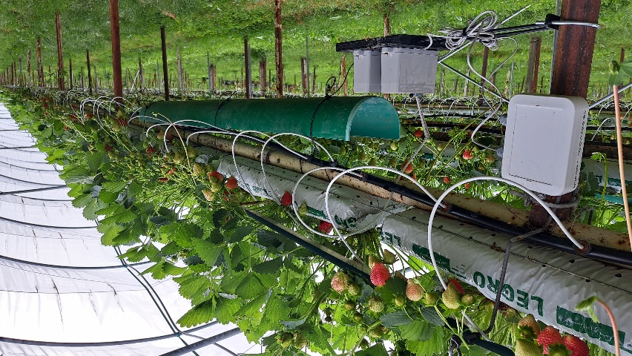
In practice, irrigation scheduling in protected strawberries must reconcile competing objectives: satisfy crop water demand to avoid stress; minimize drain (leachate) that carries dissolved nutrients off the root zone; and maintain substrate electrical conductivity (EC) within species-appropriate bounds. The term drain denotes the leachate collected after an irrigation event—the fraction of applied water that exits the substrate and is typically captured or measured in gutter and table systems. The leaching fraction (LF) is the ratio of drain volume to irrigation volume and is a key control lever for salinity management. Crop evapotranspiration (ET) quantifies the combined water lost by evaporation and plant transpiration; ET is commonly decomposed into reference evapotranspiration (ETo), representing atmospheric demand for a reference crop under standardized conditions, and crop evapotranspiration (ETc = Kc × ETo), where the crop coefficient Kc scales ETo to the crop’s phenology and canopy characteristics. Water-use efficiency (WUE) is a practical performance metric, typically expressed as biomass or yield per unit water consumed (or per unit irrigation applied plus effective rainfall), and is an explicit objective for modern irrigation strategies. Using feedback from sensors to infer the system’s current water balance—especially through the measurable signal of drain from previous irrigation events—offers a potentially robust path to automated, adaptive scheduling. Drain carries direct, observable information about substrate saturation and percolation that complements point soil-moisture sensors or tensiometers, and it is particularly useful in soilless, table-top systems where lateral flow and captured drain are the dominant hydrological processes.
Data-driven control systems, including machine learning (ML) and reinforcement learning (RL), have recently attracted interest as tools to translate multi-sensor data streams into actionable irrigation policies. RL is attractive because it frames irrigation as a sequential decision problem: at each decision point an agent selects an irrigation action to maximize long-term objectives balancing yield, WUE, and environmental constraints. However, commercial greenhouses present a fundamental constraint for RL: online exploration—allowing an agent to try novel actions and learn from consequent states—can require risky interventions that jeopardize crop health, nutrient balance or product marketability. Consequently, offline RL (also called batch RL), which learns policies from historical or simulated datasets without further risky online exploration, is an apt alternative for protected horticulture. Offline approaches hinge on the availability of sufficiently representative data and on reliable methods for offline policy evaluation, since a learned policy cannot be safely trialed in situ without strong evidence of generalizability and safety.
Empirical and modeling work in soilless strawberry systems has emphasized several recurring themes. Sensor-driven irrigation using substrate moisture probes and EC sensors can reduce water use and moderate salinity, but their spatial representativeness and maintenance burden are non-trivial in commercial settings. Drain monitoring—though less common in published datasets—has been used in research nurseries to quantify LF and to parameterize substrate water retention and percolation models. Crop ET modeling remains a cornerstone of scheduling, with FAO-56 formulations (Penman–Monteith) and crop coefficients widely used to estimate ETc from standard weather inputs. In Germany, national meteorological services provide dense ETo grids and station products that are well suited to informing greenhouse controllers, but greenhouse microclimates and shading alter the effective ET compared with outdoor crops and typically require local calibration of Kc or empirical modification of ETo inputs. On the algorithmic front, recent studies have explored RL for irrigation in orchards and field crops, often relying on simulators to generate training trajectories; these works highlight two practical realities relevant to protected strawberry systems: (i) simulator fidelity to real process dynamics is the dominant factor affecting policy transferability, and (ii) offline policy evaluation techniques are essential but still an active research area for safety-critical agricultural applications.
Against this background there are clear gaps that motivate the present study. High-quality, long-term datasets that include continuous, high-resolution drain measurements from protected German strawberry operations are scarce; available seasonal trials are often too short or too localized to capture interseasonal variability and its effect on irrigation dynamics. This scarcity magnifies the risk of covariate shift between training data—whether historical or simulated—and the true distributions encountered when a policy is deployed, particularly for drain-based signals that reflect subtle interactions among substrate structure, irrigation hardware and canopy development. Moreover, to the best of current knowledge, there are no published applications that explicitly use drain-focused feedback combined with offline RL to derive irrigation timing policies for protected strawberries under German production contexts.
The work reported here addresses these gaps through a pragmatic, simulation-anchored offline RL framework targeted at drain-based scheduling for protected strawberry cultivation in Germany. Specifically, the study (i) calibrates an evapotranspiration-drain response model for strawberries using an initial season of measured sensor data and subsequently uses public mesostation weather products to generate extended drain sequences; (ii) constructs and trains offline RL agents on the augmented dataset to learn irrigation timing policies that trade off WUE, crop water supply and drain minimization; (iii) explores two distinct episode segmentation strategies—time-fixed (daily) episodes versus event/ET-window episodes—to evaluate how episode design affects learning and offline policy evaluation; and (iv) synthesizes practice-oriented recommendations on the minimal sensor suite and dataset volume required to produce deployable, low-risk controllers for German protected horticulture. The results illuminate the promise of drain-based feedback for precision irrigation while underscoring the central role of extensive, real-world sensor collections and careful simulator calibration when moving from offline policy development to safe field deployment.

Materials and Methods 4

Results 3

Discussion 2

Conclusions

Summary of findings and outlook on future research

References

List references in alphabetical order (for citation see author's information https://www.agricultural-engineering.eu/landtechnik/about/submissions#authorGuidelines)

Authors
Provide the full names including academic titles, positions/roles, and institutional affiliations, as well as the email address of the corresponding author.

Notes or acknowledgements
e.g. information on funding bodies, project partners

